Workit
Team Brief — Simphiwe Msibi
Prepared by Tshepo M · 15 July 2026 · covers: brand kit, live growth numbers, and where operations focus goes next.

Why this document: you now have the second admin seat on Workit. This is everything in one place — how our brand looks so anything you make matches the site, and what the live numbers say we should do next. Nothing here is confidential legalese; it's the working picture.

1. Brand kit — colours & fonts
The whole product uses one warm, earthy palette — think SA summer, not corporate blue. If you make a poster, a WhatsApp status graphic, or a slide, pull from these exact colours (ochre is the hero; brick red is reserved for errors only — never use it decoratively).
Name | Swatch | Hex | Used for
Ochre 500 |  | #D97742 | Primary accent — buttons, links, active states, the brand orange
Ochre 600 |  | #B85A2A | Pressed/hover accent; prices and money amounts
Ochre 100 |  | #F5DBB5 | Soft highlight fills and badges
Sage 600 |  | #5D7A47 | Positive/success accent — approvals, worker highlights
Sage 100 |  | #E2E9D4 | Soft green fills behind success messages
Brick |  | #A93226 | Errors, rejections, destructive actions ONLY
Ink |  | #1F1612 | Headings and primary text
Ink soft |  | #4A3A30 | Body text
Ink muted |  | #7A6A5E | Secondary text, captions
Cream |  | #FAF4EC | Page background
Cream 2 |  | #F3EAD9 | Card / secondary surfaces
Line |  | #E5D9C4 | Borders and dividers
The app also ships a dark mode with the same hues re-tuned for dark surfaces — for documents and graphics, always design on Cream (#FAF4EC) or white.

Fonts
- Fraunces — display serif, used for all headings, prices, and the wordmark. Free on Google Fonts. Fallback: Georgia.
- Manrope — the body/UI font for everything else. Free on Google Fonts. Fallback: Segoe UI / system sans.
- Rule of thumb: Fraunces for the big line, Manrope for everything under it. Never more than those two fonts on one artwork.

2. Users & signups — where we are (live, 15 July)
Pulled straight from the production database this morning. Headline: 79 registered accounts — 62 workers, 17 employers. Real growth started on 9 July, the day the outreach campaigns kicked in: ±86 signups in 6 days, settling at a run-rate of 10–14 per day. (About 24 accounts — old test accounts and junk — were cleaned out on 9–11 July, so today's 79 are all real.)
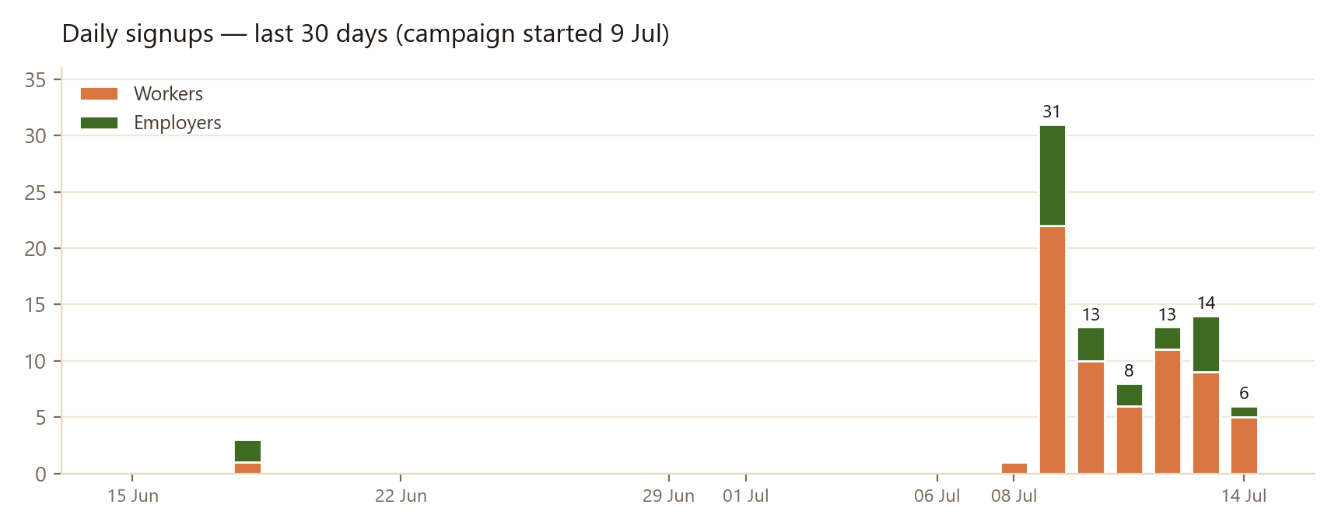
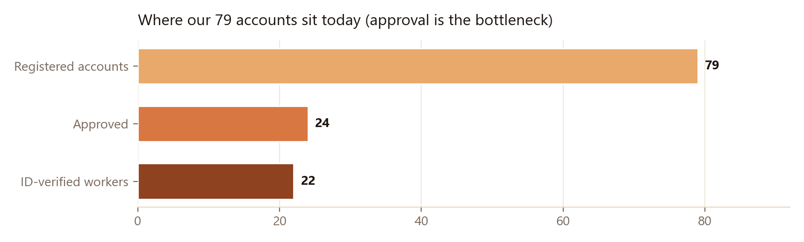
The good news: supply-side acquisition works. Workers are joining daily at basically zero cost, 22 already passed ID verification, and 26 have filled in their skills.
The gap: demand. Only ~4 jobs were posted in the whole 30 days and just 1 is open right now — 62 workers are competing for 1 job. Workers who see an empty feed will drift away, so getting employers to post is the single most important thing this month.
What's already in motion: a personal WhatsApp nudge to all 16 reachable employer accounts (drafted, Tshepo sends), offering a free boost + concierge help posting their first job. Two new product features shipped this week support this push: a payment-confirmation handshake on finished jobs, and the Work Record — a shareable proof-of-income certificate for workers (workitsa.co.za/record). Both give workers real, growing value the moment jobs flow.

3. What this means for operations (your seat)
The numbers above translate into a short daily rhythm — roughly 20–30 minutes a day right now:
- Daily approval pass. 54 of 79 accounts sit in Pending. In the admin panel the queue is split for you: “ready to review” (docs in — approve or reject same day) vs “awaiting docs” (nothing to review — send the WhatsApp/email docs reminder with one click).
- Verification reviews. Check ID docs against the fraud signals shown on each card; approve honest submissions quickly — speed here is a growth lever, workers tell each other.
- Employer approvals are instant wins. Employers have no documents — approve organic employer signups on sight so they can post.
- Welcome manuals. Every approval triggers the automatic welcome email; use the “Send welcome manual” button for anyone approved before it existed.
- Support inbox. WhatsApp support messages land in the admin Support tab — aim for same-day replies.
Two setup items for you, once: (1) enrol your authenticator app at workitsa.co.za/account/security — the admin panel requires it; (2) after Tshepo assigns your admin role, sign out and back in so it takes effect. The full how-to lives in ADMIN_GUIDE.md in the project folder.
Questions → Tshepo (tshepowayne@workitsa.co.za). Welcome aboard — the next 30 days are about turning 62 ready workers into completed, paid, rated jobs.

